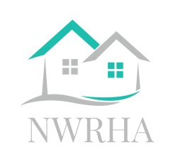**NOTICE TO MOVE / PORTABILITY**

# Northwest Regional Housing AUthority

9250 County Rd 3

Tolley, ND 58787

Phone 701-263-5240

Email nwhra@srt.com

Web site www.nwrhousing.com

Serving Bottineau, Burke, Divide, and Renville County

Tenant Name: ____________________________________________

Address:_________________________________________________

Landlord/Property Manager:

Please sign this statement that your tenant has given you the proper 30-day notice and you will be allowing the tenant to move from your unit. Indicate below the date the tenant will be released from the lease. The tenant cannot break the lease, owe you money (other than the next month rent), or damage the unit.

Date: ___________________________

To be eligible to move with continued assistance, the tenant cannot owe you any rent, other than what is owed under the 30-day notice. Please indicate below if any rent is due.

$ _____________

Thank you for your cooperation. It is the tenants responsibility to return this form to the housing authority.

Landlord/Manager Signature & Title Date

Tenant Signature Date